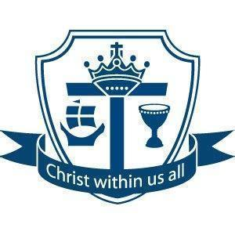
Work together; Succeed together

Year 7 Assessment 1

Information Booklet

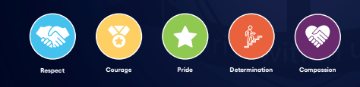
Year 7 Assessment 1
3rd November-14th November

Work together; Succeed together

During the next half term, pupils will have the first of two summative assessments. We think it is important that pupils experience exams and assessments, in Year 7, so that they can be as prepared for external examinations when they come, while at the same time ensuring this is as stress free and as supportive as possible.

Success in assessments is a team effort which involves you, the school and pupils working together and so there are many things you can do to support your child at home.

As well as the subject specific support on the next few pages, we have put together some revision tips, an assessment schedule and a revision timetable. Which we will also be talking to pupils about in assemblies and form time.

Revision Support
Subject Teachers will begin preparing pupils for their assessment over the next few days in lessons. Revision guidance and materials for each subject area is available on:
- GoogleClassroom As you will know, revision and support resources are also always available on Google Classroom which all pupils have a unique school-based login for. More information, including help videos, on how pupils can and should access this platform is available here.
- After school Subject Revision Sessions - Pupils can stay in the library to complete revision until 4pm each night.
- Helping pupils with their Mental Health during Exams - we will be running some support sessions on this to support healthy habits to reduce anxiety during exams. There are also lots of helpful resources on our website

We will be using the results and analysis of these assessments to plan revision support and adapt and personalise our curriculum offer to ensure any gaps pupils have are closed.

Year 7 English – Half Term 1 Knowledge Organiser (Fairy Tales)
Key Knowledge  • Fairy tales are traditional stories with magical elements, good vs evil, and moral lessons.  • Common character types: Hero, Villain, Princess/Damsel.  • Structure: Five-part narrative – Opening, Build-up, Climax, Resolution, Ending.  • Popular themes: Bravery, Magic, Transformation, Justice, Love.  • Why popular? Easy to retell, universal themes, moral lessons, imagination.  Key Vocabulary  • Protagonist – Main character (often hero)  • Antagonist – Opposes the hero (villain)  • Moral – Lesson about right and wrong  • Narrative – A story  • Genre – Type/category of literature  • Linear – Chronological order | Writing Skills  • Linear analysis: explain story in order with quotations.  • Analytical paragraph: Point, Evidence, Explanation, Link.  • Narrative writing: 5-part structure, first person, varied sentences.  • Literary techniques: simile, metaphor, personification, onomatopoeia.  • SPaG: accurate spelling, punctuation, grammar, consistent tense.  Success Criteria  ✓ Analyse stories with quotations and methods.  ✓ Write structured analytical paragraphs.  ✓ Plan/write own fairy tale using 5-part structure.  ✓ Use ambitious vocabulary and techniques.  ✓ Write fluently in first person with correct spelling and punctuation.

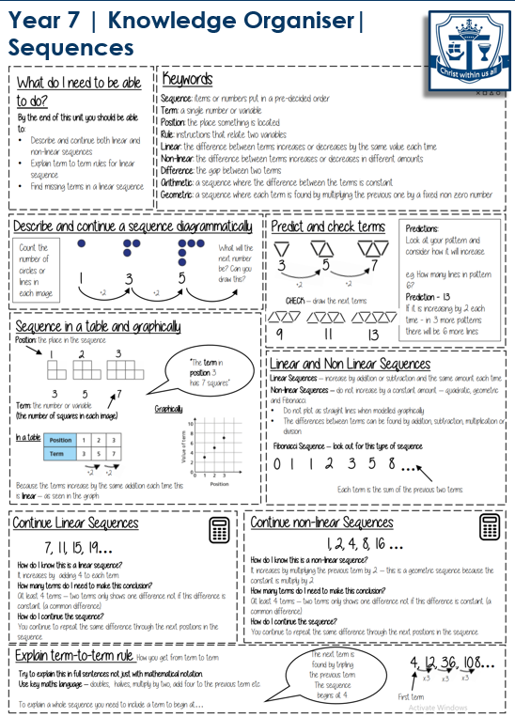

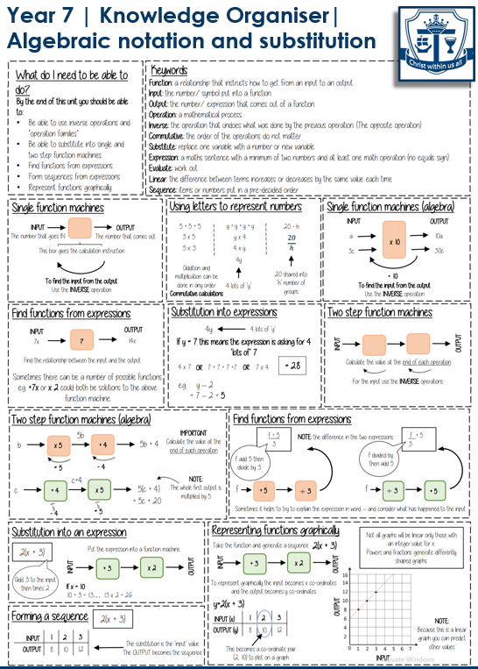

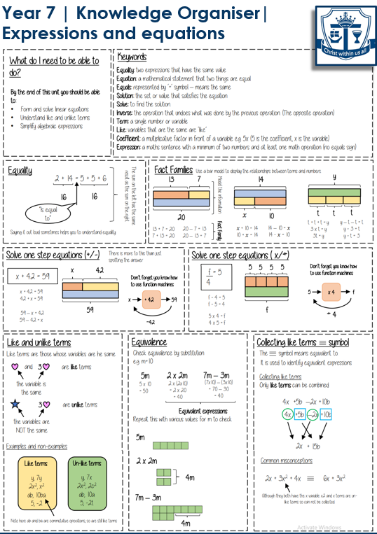
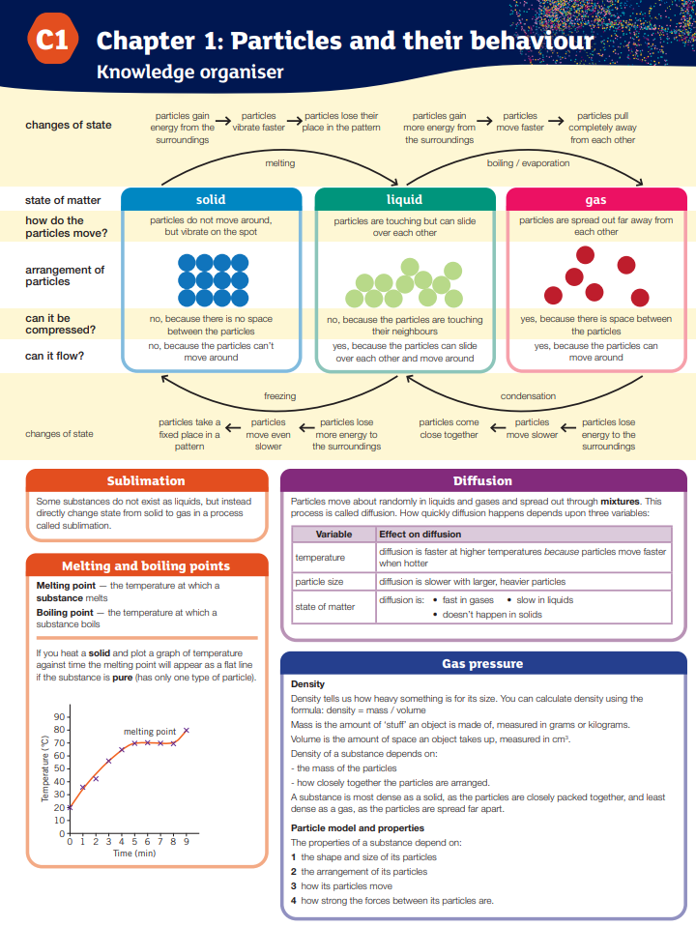

RE Year 7 Prophecy and Promise Summative Assessment Revision
Bible | The holy book of Christians, divided into the Old and New Testaments.
Hebrew | The ancient language of the Jewish people, used in the Old Testament.
Old Testament | The first part of the Bible, focusing on God's relationship with Israel before Jesus.
New Testament | The second part of the Bible, telling the story of Jesus and the early Christian Church.
Scripture | Sacred writings considered holy and authoritative, like the Bible.
Magisterium | The teaching authority of the Catholic Church, led by the Pope and bishops.
Mass | The Catholic Church’s main worship service, where the Eucharist is celebrated.
Rosary | A Catholic prayer that involves repeating prayers while meditating on events in Jesus and Mary’s lives.
Stewardship | The duty to take care of the environment for future generations.
Fundamentalist | Believe the Bible is complete truth and that it is the direct word of God.

Translating the Bible
§ The Bible wasn't always available in English. For many centuries, it was only available in languages like Hebrew, Greek, and Latin. The Church used Latin for its services, and most people couldn't read it, so they had to rely on priests to tell them what the Bible said.
§ In the 14th century, a man named John Wycliffe began to translate the Bible from Latin into English so more people could read it for themselves. Wycliffe's translation was not perfect and faced a lot of opposition from the Church, but it helped inspire others to do the same.
§ A few years later, another important translation happened: William Tyndale, who was fluent in Hebrew and Greek, translated the New Testament into English.
§ After Tyndale, English translations of the Bible continued to improve. In 1611, the King James Version (KJV) was completed, which became one of the most famous English translations ever.

Bible as a Library of Books:
The Bible is one way in which God reveals himself, communicates and gives humans important information. Revelation means how God reveals himself to humans. The Bible was written by human authors who were inspired (‘God breathed’ the belief that the Holy Spirit guided the writers) by God to write what was reveal to them and what they saw. Each book in the Bible is unique, with a different message, a different aim and a different literary style. It is not one book written by one author. It is believed there are around 40 different authors written at different times, the thing they have in common is they were guided to write through the Holy Spirit.
Hebrew Bible:
The Hebrew Bible is a collection of important books for both Jewish and Christian people. It's sometimes called the Tanakh in Judaism. It has three main parts:

The Law (Torah) | These are the first five books of the Bible. They tell stories about the beginning of the world, the first people, and the history of the Jewish people, including how they left Egypt. It also has many rules that people should follow, such as the 10 commandments.
The Prophets (Nevi'im) | Includes the history of Israel, like stories of kings and leaders (such as Joshua and Samuel).  Also includes the words of the prophets, people who shared God's messages, like Isaiah, Jeremiah, and Ezekiel.  The prophets often warned people to follow God's ways and gave hope for the future.
The Writings (Ketuvim) | This section has many different kinds of books including:  § Psalms: Songs and prayers to God.  § Proverbs: Short sayings that give wise advice.  § Job: A story about a man who suffers and wonders why bad things happen.

Subject Specific Assessment Information

Subject | Type of Assessment | What will my child be assessed on? | What can my child do to revise?
English | Short answer questions assessing information retrieval, key vocabulary and inference skills. Extended writing answers assessing analytical and writing skills | Reading skills  How a character is presented in a text, how to select relevant quotations, how to structure an analytical paragraph, how to comment on the effects of writers’ methods.  Writing skills  Writing a narrative: use a five part narrative structure, use a range of sentences with accurate punctuation, use a range of vocabulary, use literary techniques, use tenses accurately. | A revision booklet will be available on Google classroom.
Maths | 2 Written papers - One calculator, one non calculator | Papers will cover topics that have been studied in year 7 so far (Sequences, algebraic notation and substitution, expressions and equations and place value, ordering and rounding) as well retrieval topics covered in KS2. | All students will be given a revision pack to revise from as well as using Sparx to support their revision
Science | Combination of multiple choice, short answer questions and long answer questions. Including basic maths skills. | Scientific skills - including equipment, methods, presenting data and drawing conclusions.  Introduction to particles and states of matter. | Complete their daily goals on tassomai.  Complete additional weekly tasks that are set on tassomai to help students revise.
RE | A written paper with two sections:  Section 1: Keywords  Section 2: Knowledge retrieval  Section 3: Extended writing | The Creation and Covenant Unit and the Prophecy and Promise Unit of work. | Students have a knowledge organiser and they will be given an A4 Revision sheet that will also be put on google classroom.
History | A written paper with two sections:  Section 1: Keywords  Section 2:: Extended writing | Knowledge of keywords & concepts from Unit 1: Migration to Britain & Unit 2: Norman Conquest.  Extended answer on the impact of the Norman Invasion. | Students will have access to lesson resources on Google Classroom and will be given a knowledge organiser to revise from at home.
DT & Food and Nutrition | A variety of multiple choice and extended writing questions. | Food and Nutrition  - Hazards and Hygiene, Nutrients in Food  - Eatwell Guide  - Knife Safety and Skills  - Sensory Analysis  - Making Healthy Choices  Smart Materials  - Colour Theory  - CAD 2D Design  - Workshop Safety  - Timber sources and categories  - Environmental impact  - Use of machinery to manufacture  Battery Tester  - Paper Source and Processing  - Smart Materials  - Colour Theory  - CAD 2D Design | Students have their class folders for revision and knowledge organisers are provided as revision resources for all topics. Lesson powerpoints are available on google classroom to access and review.
Geography | A Written assessment consisting of a variety of multiple choice and short and longer form questions. | - Geographical skills - describing location & map skills  - Human & physical features  - Human influence on the environment | Resources can be found on Google classroom and revision materials will be handed out in class.
French | A written assessment followed by a reading/listening assessment | Responding to a question in the target language. Scanning a text and looking for detailed information in a longer text. | Students to use their sentence builders and/or knowledge organisers as revision resources for all topics. They can be found in google classroom.
Computer Science | Computer based assessment with multiple choice and written questions | Students will be assessed on:  Computational thinking, Abstraction / Decomposition / Pattern Recognition / Algorithms, Problem solving, Cyberbullying , Sharing information online and Keeping data safe | Knowledge organisers are available for each topic on Google Classroom.  Students also have access to Seneca which has a variety of learning materials and quizzes that the students can work through to help them prepare.
Art | Students will be assessed on four key areas of learning in Art, known as Personal Learning Criteria (PLC) | (PLCs): Pupils will be assessed on their ability to (PLCs):  Respond – How well they understand and apply art elements and artist influences.  Develop – How effectively they experiment with materials and techniques  .Perform – The quality of their sketchbook work, including drawing and annotation.  Evaluate – How personal, creative, and refined their final piece is.  Each pupil will be graded on four key areas: Respond, Develop, Perform, and Evaluate, with grades ranging from Developing (1–3), Confident (4–6) to Refined (7–10). | Review class notes and artist research.  Practise drawing and shading techniques at home.  Take photographs of the local environment in New Brighton to use as primary source material.  Ensure sketchbook work is complete and well-presented.  Use teacher feedback to improve.  Refine ideas for their final piece.
Music | Group Composition and Solo performance on Keyboard | Students follow a robust music curriculum founded on four learning criteria - Performing, Composing (and Improvising), Appraising and Singing. Students are continuously assessed as they work through principles with an increased level of sophistication. There are two summative tests that form part of Assessment 1 - Composing a Rhythm piece in a group of 4 and Performing Ode to Joy on Keyboard. | There are no requirements for revision as all the work is prepared in the classroom. However, each student should be encouraged to participate fully in the process.
Drama | Practical application and performance | Assessment takes place each lesson in relation to key skills and conventions and how the students respond, develop and evaluate .  They are then assessed on the application of all knowledge through a practical piece where they apply the skills explored in a final peformance. | Students can research Greek Theatre and the medium of masks. They will also be provided with a revision sheet on google classroom on the skills explored.
Dance | Practical and performance application and analysis. | Assessment takes place each lesson, assessing on the key skills and techniques and how the students respond, develop and evaluate.  Each student will be assessed through practical exploration and application and the skills explored in their final performance. | Students will be able to research conventions in dance on BBC bitesize, partially focusing on choreography and motif development.
PE | Practical Assessment | Courage & Compassion classes-  Basketball  Rugby  Football  Gymnastics  Health & Fitness  Trampolining  Handball  Orienteering  Badminton  Leadership  Rounders  Athletics  Pride & Respect Classes  Netball  Football  Aerobics  Orienteering  Health & Fitness  Leadership  Gymnastics  Rounders  Athletics | Students can use their Google Classroom and also youtube to research the rules and regulations for each sport along with each learning intention

Revision Tips

There is no correct way to support learners when preparing for assessments. Choose the approaches that work best for you, your family, and your situation. Below are a few suggestions you may wish to trial.
- Talk to your child about their upcoming assessments.
- Ask them how you can help.
- Try to provide a quiet space for your child to complete homework/revision.
- Encourage your child to think creatively about revision e.g. Record facts/ revision notes on your phone/ laptop, make your revision notes into a podcast, listen to it a couple of times a day.
- Talk to your child about having their mobile phone in another room when completing homework/revision.
- Ensure learners get enough sleep. Regular bedtimes, and wake times, will help concentration spans.
- Set your child a challenge. For example, you could ask them to revise a short topic; using the revision resources, you could then ‘test’ them on what they have just revised.
- Talk to your child about the importance of trying to get their 5-a-day, enough exercise.
- Encourage your child to drink lots of water.
- Ensure they take adequate breaks.
- Stay positive. Look for ways in which you can help them to believe in themselves by reminding them of the successes they have had.
- If there are any revision sessions/intervention at school that your child has been invited to, encourage them to attend.
- Remember teachers will set homework tasks that will count towards preparation/revision for the assessment.
- Children should avoid ‘just’ reading a revision guide; always try and build some activity or interactivity e.g. summarise in their own words, draw and label diagrams, get someone to test them, use online resources that the school has to offer; Google Classroom; Sparx Maths, QUIZLET, Seneca learning, Educake.
- Below are some example revision strategies you can use:
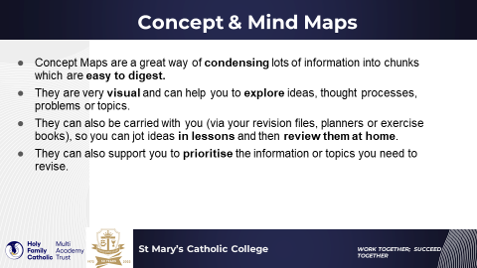

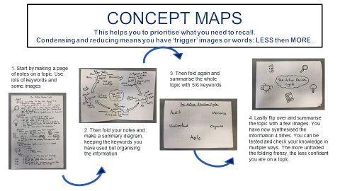

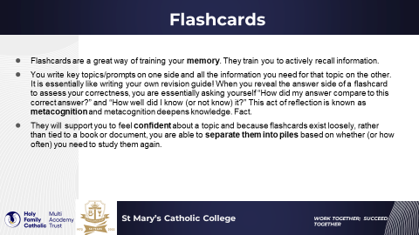

Assessment Schedule

Use this schedule to allow you to know when your assessments are so you can best plan your revision.
Day/Date | Monday 3rd November | Tuesday 4th November | Wednesday 5th November | Thursday 6th November | Friday 7th November
Period 1
Period 2
Period 3
Period 4
Period 5

Day/Date | Monday 10th November | Tuesday 11th November | Wednesday 12th November | Thursday 13th November | Friday 14th November
Period 1
Period 2
Period 3
Period 4
Period 5

Revision Timetable

Use the revision timetable below to plan your revision. You should be revising your core subjects of English, Maths, Science and RE at least three times per week. Your other subjects you should be revising at least twice per week. Create a colour key for each subject and dot the colour on your revision timetable when you will revise that subject.
For example:
English Red, Maths Blue, Science Yellow

