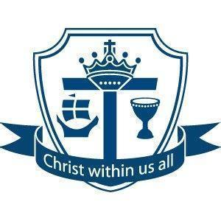
Work together; Succeed together

Year 8 Assessment 1

Information Booklet

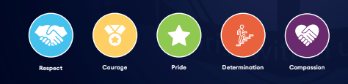
Year 8 Assessment 1
3rd November - 14th November

During the next half term, pupils will have the first of two summative assessments. We think it is important that pupils experience exams and assessments, in Year 8, so that they can be as prepared for external examinations when they come, while at the same time ensuring this is as stress free and as supportive as possible.

Success in assessments is a team effort which involves you, the school and pupils working together and so there are many things you can do to support your child at home.

As well as the subject specific support on the next few pages, we have put together some revision tips, an assessment schedule and a revision timetable. Which we will also be talking to pupils about in assemblies and form time.

Revision Support
Subject Teachers will begin preparing pupils for the Assessments over the next few weeks in lessons. Revision guidance and materials for each subject area is available on:
- GoogleClassroom As you will know, revision and support resources are also always available on Google Classroom which all pupils have a unique school-based login for. More information, including help videos, on how pupils can and should access this platform is available here.
- After school Subject Revision Sessions - Pupils can stay in the library to complete revision until 4pm each night.
- Helping pupils with their Mental Health during Exams - we will be running some support sessions on this to support healthy habits to reduce anxiety during exams. There are also lots of helpful resources on our website.
- We will be using the results and analysis of the end of year assessments to plan summer revision support and adapt and personalise our curriculum offer, next year, to ensure any gaps pupils have, are closed.

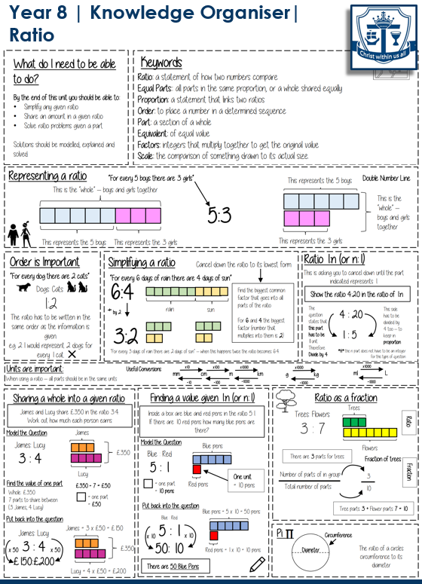

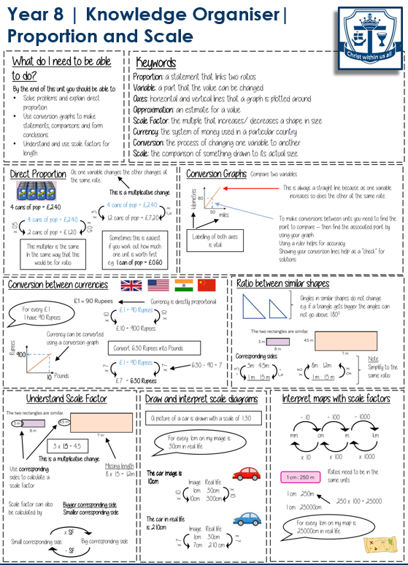

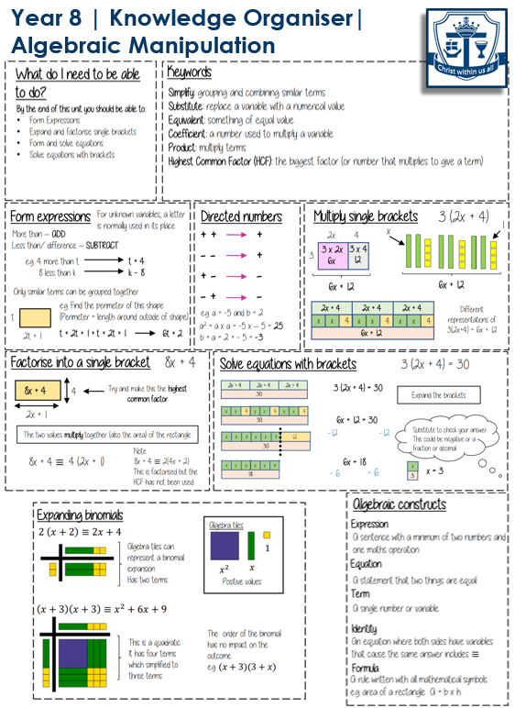

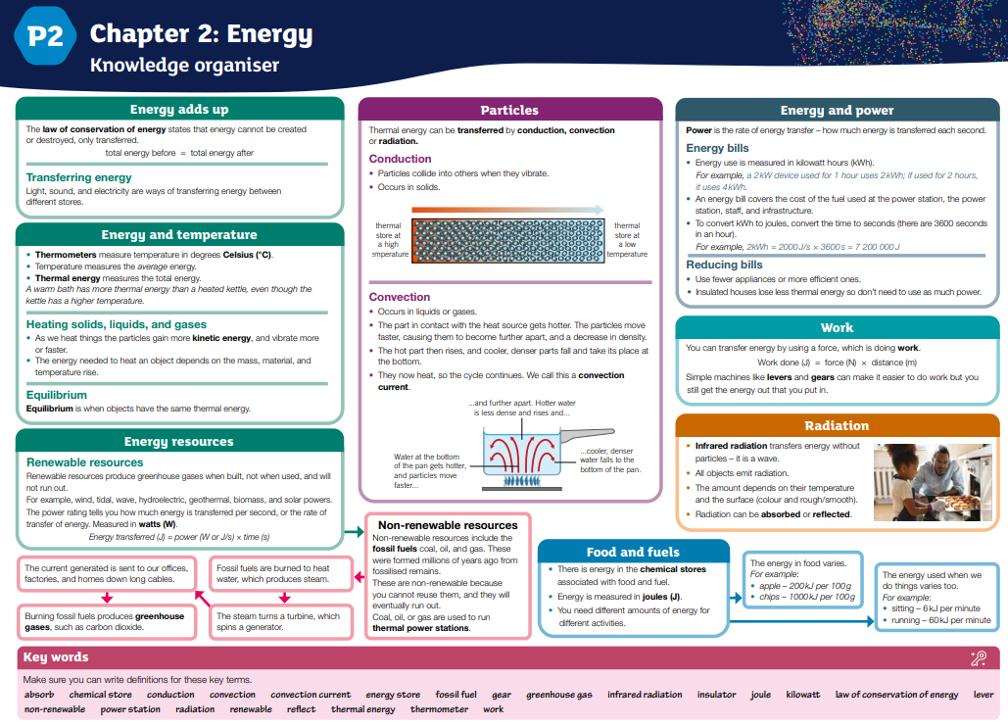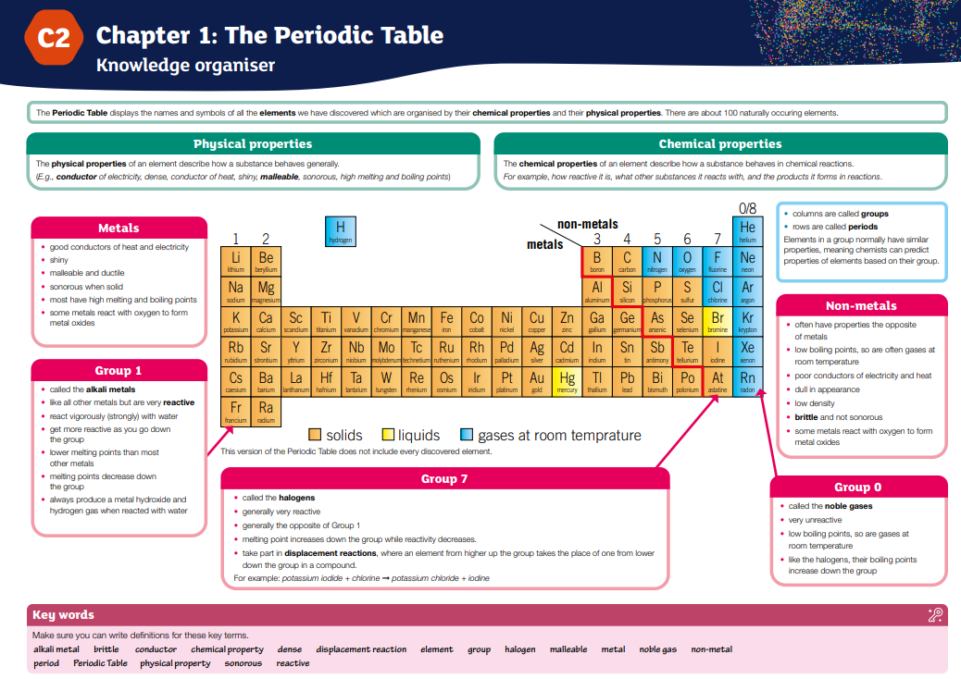Year 8 English – Half Term 1 Knowledge Organiser (Animal Farm)
Key Knowledge
• Animal Farm is an allegory about the Russian Revolution and rise of Stalin.
• Genre: Political allegory and dystopia.
• Allegory: A story with a hidden meaning, often political or moral.
• Dystopia: A text showing an unjust, oppressive society.
• Context: Written in 1945 by George Orwell, critiquing totalitarianism.
• Key Themes: Power & Corruption, Propaganda & Control, Class & Inequality, Betrayal, Leadership.
• Key Characters:
- Old Major: Inspires revolution with utopian vision.
- Napoleon: Represents Stalin, corrupt dictator.
- Snowball: Represents Trotsky, intelligent but exiled.
- Boxer: Loyal, hardworking, exploited.
- Squealer: Propaganda and persuasion.
Writing Skills  • Conceptual analysis: exploring ideas/themes across the text.  • Analytical paragraphs: Point, Evidence, Explanation, Wider Concept.  • Critical arguments: Structured, evidence-based discussion.  • Contextual links: Relating text to historical/political background.  • Literary methods: rhetoric, symbolism, irony, satire. | Key Vocabulary  • Allegory – Story with symbolic meaning.  • Dystopia – Imagined world of suffering/oppression.  • Propaganda – Biased communication to influence.  • Tyranny – Cruel and oppressive rule.  • Revolution – Forcible overthrow of authority.  • Totalitarianism – Complete control by the state.

RE Year 8 Prophecy and Promise Summative Assessment Revision
Prophet | A person regarded as an inspired teacher or messenger of the will of God.
Three-Fold Office of the Church | The Church as Priest, Prophet and King.
Laity | People who go to Church, but are not priests or deacons. The congregation.
Ministry | Serving others in the way that shows the love of God. Jesus’ ministry includes how he acted and his teachings.
John the Baptist | Jesus’ cousin, who baptised Jesus in the River Jordan.
Advent | A time of waiting and preparation for the celebration of the birth of Jesus.
Jesse Tree | A tradition that happens during Advent that helps tell the story of the Bible leading up to the birth of Jesus.
Original Sin | The sin Catholics believe we are born with because Adam and Eve disobeyed God.
Covenant | A promise or agreement between two parties
Conscience | An inner feeling of the rightness or wrongness of an action.

Prophets
A prophet is a person seen as an inspired teacher or messenger, sent by God with a message for people. The Bible is full of prophecies, which is a prediction of what will happen in the future.

There are many important prophets in the Old Testament, including:
Prophet | Their message from God
Jeremiah | Jeremiah warned the people of Judah about punishment for their sins but also promised that God would one day give them a new heart to follow him.
Amos | Amos called out the people of Israel for being unjust and treating the poor badly, reminding them that true worship means caring for others.
Isiah | Isaiah warned of judgment but also shared hope about the Messiah, who would bring peace and justice.
Elijah | Elijah challenged the worship of false gods, urging the people to stay faithful to the true God and trust in his power.

Three-Fold-Office of the Church
The Church is a group of people who follow Jesus, and just like Jesus had special jobs to do when he was on Earth, the Church also has special jobs to do. These jobs are called the Threefold Office of the Church, and they are based on three things Jesus did:
1. Prophet: A prophet is someone who tells others what God wants them to know. Jesus was like a prophet because he shared God’s truth with everyone. The Church does this by teaching and telling people about God’s love, what the Bible says, and how to live the way God wants us to.
2. Priest: A priest is someone who helps connect people with God, especially through prayer and worship. Jesus was like a priest because he helped people pray to God and made sure they could have a close relationship with God. The Church does this by leading people in prayer, offering sacrifices (like Jesus did), and helping people feel close to God.
3. King: A king is someone who leads and cares for people. Jesus was a king because he led people in doing what is good and right. The Church does this by helping guide people to make good choices, keeping the community safe, and making sure everyone is treated fairly.
John the Baptist: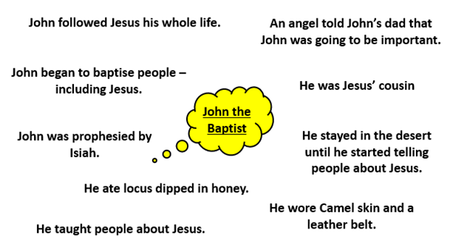

Subject Specific Assessment Information
Subject | Type of Assessment | What will my child be assessed on? | What can my child do to revise?
English | Reading and writing assessment of one lesson duration | Students will be assessed on comprehension, device recognition, inference and analysis in the reading section; students will be assessed on content, organisation, vocabulary, spelling and sentence structure in the writing section | Reading regularly for pleasure is the best way any student can improve their outcomes in English.  Students will be provided with a revision booklet to help them revise for the reading section of the exam.  Students will be provided with a set of titles to choose from to help them prepare for the written section of their exam. They can plan their stories and/ or practise writing them.
Maths | Written assessment with 1 lesson duration | Students will be assessed on their cumulative learning up to and including half term 3 of this year. Specifically, the topics studied so far this year are Ratio & Scale, Multiplicative Change, Multiplying & Dividing Fractions, Working in the Cartesian Plane, Representing Data, Probability, Brackets Equations & Inequalities, Sequences and Indices. | Students have been given a revision booklet with Sparx clips for every area studied this year as well as knowledge organisers giving more detail of skills and areas of study
Science | Written assessment taking 42 minutes (allowing for extra time where needed) | Students will be assessed on their cumulative knowledge through a mix of multiple choice, short answer and long answer questions. Topics will include those studied so far this year (periodic table, digestion, energy, chemical reactions, light and photosynthesis/respiration) as well as appropriate year 7 knowledge. | Students will be given revision materials by their class teacher through Google Classroom.
RE | Written Assessment | Students will be assessed on one example from the gospels of Jesus' encounters with those on the margins, and explain how Jesus reveals God's nature towards marginalised people through the care he shows.  Also, students will be assessed on the work of organisations dedicated to reaching out to marginalised people. In addition, students should be able to explain how miracles show Jesus' power, and make connections between the parables & miracles of Jesus, and Catholic beliefs about the Kingdom of God. | Students can access all lesson resources & revision material in Google Classroom.
History | Written Assessment | Assessment will be divided between a knowledge test based on topics studied this year to date & an extended written task:  1 x Section A knowledge test - covering units 1-3  1 x Section B - extended writing task - use of historical evidence | Students can access the revision resources in Google Classroom
DT & Hospitality | Assessment based on the topic areas covered year to date | Compassion & Courage | Access Knowledge Organiser via Google Classroom
DT & Hospitality | Assessment based on the topic areas covered year to date | Determination | Access Knowledge Organiser via Google Classroom
DT & Hospitality | Assessment based on the topic areas covered year to date | Pride | Access Knowledge Organiser via Google Classroom
Geography | Written Assessment. | The assessment is a mixture of short knowledge retrieval questions and longer application questions where students will demonstrate and elaborate their understanding.  Unit 7.1: Geography Skills/ Maps/ describing location/  Unit 7.2 - Rivers and the water cycle.  Unit 7.4 - Employment sectors and education levels.  Unit 8.1 - Weather and climate change  Unit 8.2 - Drought, economic development and the poverty cycle, importance of education for social development. | Students can use their books to create flashcards - a learning checklist will be uploaded to Google Classroom before half term. The best method is a question on one side and the answer summarised on the back. This can be tested regularly.  Complete the Seneca assignments which have been set as weekly homework. Links are on Google Classroom.  An app can be downloaded for all devices.  Login with Google and use the school login details.  Visit BBC bitesize and create a knowledge organiser of the connections between the units.  https://senecalearning.com/en-GB/  https://www.bbc.co.uk/bitesize/subjects/zrw76sg
French | Assessment based on topics studied in Class  Year 8 : LA MODE | Writing-Reading-Translation skills in French | Log on to Google Classroom and revise the new vocabulary set since 5th January. Ask their teachers directly for paper copies
Computer Science | Online assessment on all units covered | Year 8  All Y7 UoW  UnitS 1-3 Y8 UoW  Year 9  All Y7 UoW  All Y8 UoW  Units 1 - 3 Y9 UoW  KS3 Curriculum Map | All revision materials available on Google Classroom
Art | Final representational art work | Students will create a clay tile representing social justice issues. They will be marked on their composition of technique and application of design.
Music | Practical assessment | Pupils will create a character theme for a Video Game, using elements of music such as tempo, dynamics and instrumentation to describe their chosen character. | Listen to music from video games or film music in order to experience the way in which composers use the elements of music to create imagery and a mood.  https://www.youtube.com/watch?v=bWZy1hDxr9A
Drama | Practical assessment | 1 x practical assessment performance in lesson | Pupils will be assessed on their application of skills and techniques expired during their exploration of Protest Theatre. This assessment performance will be based on their learning of skills and techniques taught in term 1 and Term 2 to date.  The practical requirements will be shared with students. A recap of drama skills, conventions and techniques will be posted on Google Classroom.
Dance | Practical assessment | 1 x practical assessment performance in lesson | Pupils will be assessed on their application of skills and techniques expired during their exploration of Protest Theatre. This assessment performance will be based on their learning of skills and techniques taught in term 1 and Term 2 to date.  The practical requirements will be shared with students. A recap of dance skills, choreography and performance techniques will be posted on Google Classroom.
PE | Practical Assessment | Year 8 Boys Group: Students will be assessed on their application of knowledge of:  How to use a range of advanced techniques to improve their performance in Trampolining  How to analyse performance compared to previous ones at an advanced level to improve performance in Fitness activities  Year 8 Girls/Mixed Group:  Students will be assessed on their application of knowledge of:  How to use a range of basic tactics and strategies to overcome opponents in direct competition through Badminton  Pupil will know how to analyse performance compared to previous ones at a advanced level to improve performance | Pupils can use the following links to reinforce their knowledge of strategies and techniques to support practical application:  Boys PE  Rules of Rugby  The rules of Basketball  Girls/Mixed Groups  Components of Skill Related Fitness Resource  Badminton Shot Selection  Girls/Mixed Groups  Components of Skill Related Fitness Resource  Badminton Shot Selection

Revision Tips

There is no correct way to support learners when preparing for assessments. Choose the approaches that work best for you, your family, and your situation. Below are a few suggestions you may wish to trial.
- Talk to your child about their upcoming assessments.
- Ask them how you can help.
- Try to provide a quiet space for your child to complete homework/revision.
- Encourage your child to think creatively about revision e.g. Record facts/ revision notes on your phone/ laptop, make your revision notes into a podcast, listen to it a couple of times a day.
- Talk to your child about having their mobile phone in another room when completing homework/revision.
- Ensure learners get enough sleep. Regular bedtimes, and wake times, will help concentration spans.
- Set your child a challenge. For example, you could ask them to revise a short topic; using the revision resources, you could then ‘test’ them on what they have just revised.
- Talk to your child about the importance of trying to get their 5-a-day, enough exercise.
- Encourage your child to drink lots of water.
- Ensure they take adequate breaks.
- Stay positive. Look for ways in which you can help them to believe in themselves by reminding them of the successes they have had.
- If there are any revision sessions/intervention at school that your child has been invited to, encourage them to attend.
- Remember teachers will set homework tasks that will count towards preparation/revision for the assessment.
- Children should avoid ‘just’ reading a revision guide; always try and build some activity or interactivity e.g. summarise in their own words, draw and label diagrams, get someone to test them, use online resources that the school has to offer; Google Classroom; Sparx Maths, QUIZLET, Seneca learning and Tassomai.
- Below are some example revision strategies you can use:
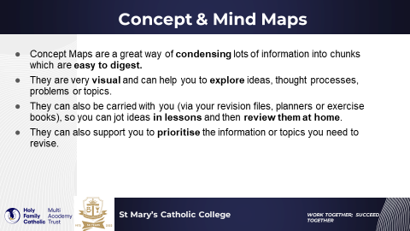

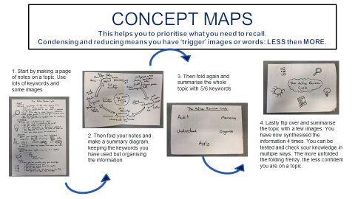

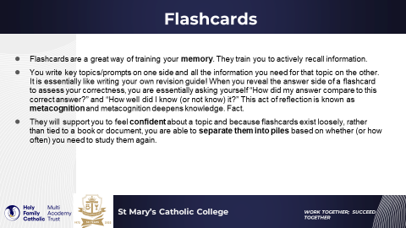

Assessment Schedule

Use this schedule to allow you to know when your assessments are so you can best plan your revision.

Day/Date | Monday 3rd November | Tuesday 4th November | Wednesday 5th November | Thursday 6th November | Friday 7th November
Period 1
Period 2
Period 3
Period 4
Period 5

Day/Date | Monday 10th November | Tuesday 11th November | Wednesday 12th November | Thursday 13th November | Friday 14th November
Period 1
Period 2
Period 3
Period 4
Period 5

Revision Timetable

Use the revision timetable below to plan your revision. You should be revising your core subjects of English, Maths, Science and RE at least three times per week. Your other subjects you should be revising at least twice per week.

